Marathwada Shikshan Prasarak Mandal’s

Deogiri Institute of Engineering and Management Studies, Aurangabad

**Project Report**

on

DC storage (DAPP)

Submitted By

Rutuja Umakant More (46062) (CSE BE-A )

Group 18

Dr. Babasaheb Ambedkar Technological University Lonere (M.S.)



# Department of Computer Science and Engineering

Deogiri Institute of Engineering and Management Studies,

Aurangabad

# (2021- 2022)

**Project Report**

**on**

DC storage (DAPP)

Submitted By

**Rutuja Umakant More (46062) (CSE BE-A )**

**In partial fulfillment of**

**Bachelor of Technology**

**(Computer Science & Engineering)**

Guided By

**Mr. K. V. Reddy**

Department of Computer Science & Engineering

**Deogiri Institute of Engineering and Management Studies,**

**Aurangabad**

(2021- 2022)

**CERTIFICATE**

This is to certify that, the Project entitled “**DC-Storage”** submitted by

**Rutuja Umakant More** is a bonafide work completed under my supervision and guidance in partial fulfillment for award of Bachelor of Technology (Computer Science and Engineering) Degree of Dr. Babasaheb Ambedkar Technological University, Lonere.

Place: Aurangabad

Date:14/01/2022

**Mr K. V. Reddy Mr. S.B. Kalyankar**

**Guide Head**

**Dr. Ulhas D. Shiurkar**

**Director,**

**Deogiri Institute of Engineering and Management Studies,**

**Aurangabad**

**DECLARATION**

This is to certify that, the partial project report entitled , “DC-Storage” Submitted by **Rutuja Umakant More** is a bonafide work completed under my supervision and guidance in partial fulfillment for award of Bachelor degree in Computer Science and Engineering of Deogiri Institute of Engineering and Management Studies, Aurangabad under Dr. Babasaheb Ambedkar Technological University, Lonere.

Place: Aurangabad

Date: 14/01/2022

Mr. K. V. Reddy

External Examiner Guide

**Abstract**

The blockchain is an innovative technology which opened doors to new applications for solving numerous problems in distributed environments. In this work, we design a blockchain based data storage and access framework worldwide end-to-end Internet performance measurement project to remove its total dependence on a centralized repository.

DC Storage is a DAPP (Decentralized Application). It is cloud-like storage where one can access/retrieve, upload data or applications over the internet. Blockchain storage costs can reduce the price of cloud computing. It not only handles storage but also protects and recovers and is transparent to users and also gives high security and privacy to data.

As no central entity or organization can control this so no one can dominate and act as a gatekeeper. Anyone can upload any type of data like docs, images and also one can upload uncensored data because no government or organization can handle it/ control it. Example original news can never be tempered.

To develop a prototype of the proposed architecture we make use of Ethereum, MetaMask, Web3.js, react.js and IPFS

**Keywords:** Storage, Decentralize, Blockchain, Etherum, Ganache, Solidity, Smart contracts.

###### **Contents**

1. **INTRODUCTION 7** 
   1. Introduction
   2. Description of Project
   3. Necessity
   4. Objectives
   5. Theme of the Project

1. **LITERATURE Review 12**

1. **SYSTEM DEVELOPMENT 14**

3.1 Specification/features and Requirement

3.1.1 DFD (level 0,1,2)

3.2 Specification Document/UML Diagrams of all modules

3.3 Architecture

3.4 User Interface Design

**4. Screenshots 20**

**5.** **PERFORMANCE EVALUATION** **22**

**6. CONCLUSION 23**

**REFERENCES**

**ACKNOWLEDGEMENT**

**Chapter No. : 01**

**1.1 Introduction**

Decentralization refers to the transfer of control and decision-making from a centralized entity (individual, organization, or group thereof) to a distributed network. Unlike a centralized server operated by a single company or organization, decentralized storage systems consist of a peer-to-peer network of user-operators who hold a portion of the overall data, creating a resilient file storage sharing system.

Blockchain strorage is a way of saving data in a decentralized network, which utilizes the unused hard disk space of users across the world to store files. The decentralized infrastructure is an alternative to centralized cloud storage and can solve many problems found in a centralized system.

A blockchain is essentially a distributed database of records or public ledger of all transactions or digital events that have been executed and shared among participating parties. Each transaction in the public ledger is verified by consensus of a majority of the participants in the system. And, once entered, information can never be erased. The blockchain contains a certain and verifiable record of every single transaction ever made. Bitcoin, the decentralized peer­to­peer digital currency, is the most popular example that uses blockchain technology. The digital currency bitcoin itself is highly controversial but the underlying blockchain technology has worked flawlessly and found a wide range of applications in both the financial and non­financial world.

It is cloud-like storage where one can access/retrieve, upload data or applications over the internet. Blockchain storage costs can reduce the price of cloud computing. It not only handles storage but also protects and recovers and is transparent to users and also gives high security and privacy to data.

As no central entity or organization can control this so no one can dominate and act as a gatekeeper. Anyone can upload any type of data like docs, images and also one can upload uncensored data because no government or organization can handle it/ control it. Example original news can never be tempered.

The advantages of Blockchain technology outweigh the regulatory issues and technical challenges. One key emerging use case of blockchain technology involves “smart contracts”. Smart contracts are basically computer programs that can automatically execute the terms of a contract. When a pre-configured condition in a smart contract among participating entities is met then the parties involved in a contractual agreement can be automatically made payments as per the contract in a transparent manner.

**1.2 Description of Project**

So to create DAPP with the help of solidity which is an object-oriented, HLL (High-Level Language) on the Ethereum network for implementing smart contracts. Now Ganache is in the role where it is used to test DAPP in a safe environment means to add a smart contract on blockchain first it will go through ganache. Ganache is a tool used to set up an Ethereum network in this case DC storage is for testing solidity contracts.

To access DC storage through web browsers Reactjs is used, as react will communicate with blockchain through web3js.

In this report, we focus on the disruption that every industry in today’s digital economy is facing today due to the emergence of blockchain technology. Blockchain technology has potential to become the new engine of growth in digital economy where we are increasingly using Internet to conduct digital commerce and share our personal data and life events.

**1.3 Necessity**

* Prevents Data Tampering

One of the major concerns during cloud storage is ensuring that the original data has not been tampered with. The inherent verifiable architecture of Blockchain offers a trusted way to track the storage and backup history and confirm that the original data has not been tampered with. Instead of storing data, it stores only the encrypted hashes of related data blocks thus providing the footsteps of the data to verify its originality.

* Strong Tracking Provisions

By sequentially linking the different blocks through cryptographic hashes the Blockchain automatically organizes the data in a verifiable order. As every single block is linked to the previous ones, it produces a decentralized, encrypted, and verifiable transaction ledger in a distributed form.

* Transparency

Blockchain provides complete transparency which simply means that any shady activity in the network can no longer remain in shadow. Moreover, its sequential storage ensures that each transaction can be verified at any time. By creating a strong, organized, and interconnected mesh of blocks the Blockchain-based cloud storage also facilitates immutable transaction records to verify ownership and identity.

* Self Sustainable Mechanism

Blockchain's distributed and hash encrypted ecosystem helps in building a trustworthy ecosystem and proactively protects against handling and fraud while reassuring that no compliances are breached by any member.

* **Security**Handing data off to a public cloud provider poses security and privacy concerns. Breaches in in cloud services continue to be reported by the media. The latest US election raised related issues. There have been notorious hacks of Apple's personal cloud system, a scandal involving loss of privacy of Uber users, and many more examples to consider.
* **Speed**Another potential downside of public cloud storage pertains to download and transfer speeds (i.e. bandwidth). Despite the fact that cloud storage has achieved some good results on benchmark tests, one of the barriers to universal adoption is that time is wasted on downloading and uploading files.
* **Compliance**In some heavily regulated industries, it is just too unworkable to use the public cloud. Healthcare providers, financial and publicly traded companies have to tread very carefully if considering the public cloud.

**1.4 Objectives**

DC-Storage allows digital information to be recorded and distributed, but not edited. In this way, a blockchain is the foundation for immutable ledgers, or records of transactions that cannot be altered, deleted, or destroyed.

Scope of Using Blockchain Technology in Cloud Computing;

The major areas where blockchain has the potential to provide improvements in comparison to existing cloud solutions are:

The blockchain system due to its unique features can be very beneficial in the field of functionality or performance enhancement. Being a decentralized system, blockchain can provide great help in establishing architecture where several computers can work at the same time for one task like storage or processing of data which can reduce the overall time of the operation and enhance the speed of processing and uploading data.

Also, there is an aspect of improvements in security in cloud computing. Cloud computing generally deals with a large amount of data, so there is always a risk of data insecurity as cloud computing works on a centralized architecture, because of this there is a possibility of the central server being hacked by hackers and in that case, the whole system will collapse and also there will be no backup of data so lost data can’t be recovered. So there is the scope of using blockchain in cloud computing for solving these issues.

**1.5 Theme of the Project**

Blockchain is a business-focused WordPress theme that's ideal For cryptocurrency and ICO related websites/Apps. Created by the CSSIgniter team, Blockchain has a professional design that makes it a great choice for creating business websites/Apps.

In recent years, cloud storage has emerged as the preferred option for more and more businesses owing to its flexibility, capacity, and easy data access. Moreover, reputed cloud storage providers such as Alibaba Cloud offer strong data encryption and other reliable provisions to ensure maximum security. Many companies have shifted their data centers onto the cloud due to high redundancy, load balancing, data integrity, and backup options.

One of the latest trends that are poised to gain momentum is to use Blockchain technology for cloud storage. There are many advantages of Blockchain-based cloud storage

In Blockchain-based cloud storage, data is divided into multiple encrypted segments that are interlinked through a hashing function. These secured segments are distributed across the network and each segment resides on a decentralized location. There are strong security provisions like transaction ledgers, encryption through pubic/private key, and hashed blocks. It assures reliable and robust security against hackers. Even advanced hackers are unable to decrypt the data due to the sophisticated 256-bit encryption.

Let's look into an unlikely case of some hackers decrypting the data. Even in such scenario, each tedious decryption attempt leads to just a small segment of data being decrypted and not the entire file. The extreme security provisions not only discourage malicious hackers but also make hacking a useless pursuit from a commercial point of view due to extreme efforts required for trivial achievements (and very high probabilities of failures).

Another important thing to consider is that the owners' data is not stored on the node. It helps owners to retain their privacy. There are strong provisions for load balancing as well.

**Chapter No. : 02**

**Literature Review**

The demand for Blockchain innovation and the significance of its application has inspired ever-progressing exploration in various scientific and practical areas. Even though it is still in the initial testing stage, the blockchain is being viewed as a progressive solution to address present-day technology concerns, such as decentralization, identity, trust, character, ownership of data, and information-driven choices. Simultaneously, the world is facing an increase in the diversity and quantity of digital information produced by machines and users. While effectively looking for the ideal approach to storing and processing cloud data, the blockchain innovation provides significant inputs. This article reviews the application of blockchain technology for securing cloud storage.

Blockchain platforms and languages for writing smart contracts are becoming increasingly popular. However, smart contracts and blockchain applications are developed through non-standard software life-cycles, in which, for instance, delivered applications can hardly be updated or bugs resolved by releasing a new version of the software. Therefore, this systematic literature review oriented to software engineering aims at highlighting current problems and possible solutions concerning smart contracts and blockchain applications development.

Cloud storage is one of the leading options to store massive data, however, the centralized storage approach of cloud computing is not secure. On the other hand, Blockchain is a decentralized cloud storage system that ensures data security. Any computing node connected to the internet can join and form peers network thereby maximizing resource utilization. Blockchain is a distributed peer to peer system where each node in the network stores a copy of blockchain thus making it immutable. In the proposed system, the user's file is encrypted and stored across multiple peers in the network using the IPFS (InterPlanetary File System) protocol. IPFS creates hash value. The hash value indicates the path of the file and is stored in the blockchain. This paper focuses on decentralized secure data storage, high availability of data, and efficient utilization of storage resources.

DC storage is about cloud like storage using blockchain which will create block as every time file gets uploaded on it.

when one will pay gas fee for this using wallet block will created at that time and will be added to the blockchain. That's how DC storage can achieve the decentralised cloud storage.

**Chapter No. : 03**

**System Development**

**3.1 System Features and Requirements**

**1] System Features:**

Payment processing: no need to integrate with a fiat payment provider to accept funds from users, as users can transact directly using cryptocurrencies,

* User credentials: using a system of public and private keys, users can transact and bind their user sessions and metadata easily and with varying degrees of anonymity, negating the need for lengthy sign-up or registration processes
* Trust and auditability: open-source DAPP code is accessible and understandable to savvy users. This transparency and the inherent security of the inclosed data generates confidence in the applications.

A public record on the blockchain also makes transaction information easy to audit by users or third-parties

**2] Requirements:**

Ganache :Ganache is an Ethereum simulator that makes developing Ethereum applications faster, easier, and safer. It includes all popular RPC functions and features (like events) and can be run deterministically to make development a breeze. Fork any Ethereum network without waiting to sync Ethereum json-rpc support

Metamask: MetaMask is a software cryptocurrency wallet used to interact with the Ethereum blockchain. It allows users to access their Ethereum wallet through a browser extension or mobile app, which can then be used to interact with decentralized applications.

IPFS: The InterPlanetary File System is a protocol and peer-to-peer network for storing and sharing data in a distributed file system. IPFS uses content-addressing to uniquely identify each file in a global namespace connecting all computing devices

Truffle: A world class development environment, testing framework and asset pipeline for blockchains using the Ethereum Virtual Machine (EVM),

web3js: web3.js is a collection of libraries that allow you to interact with a local or remote ethereum node using HTTP, IPC or WebSocket.

React: React is a free and open-source front-end JavaScript library for building user interfaces based on UI components. It is maintained by Meta and a community of individual developers and companies. React can be used as a base in the development of single-page or mobile applications.

**3.2 UML Diagram**

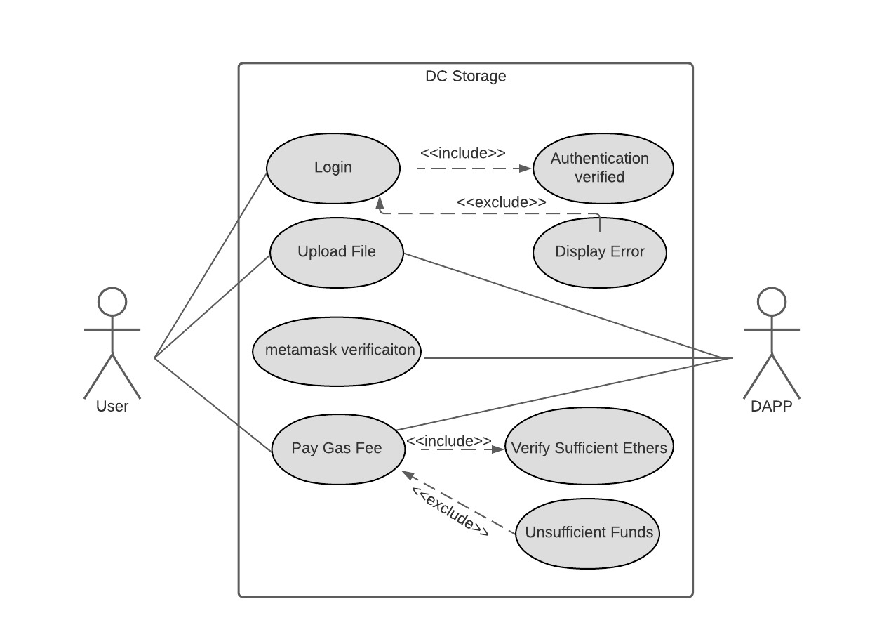

Image No.: 01 UML-Used Cased diagram

The UML Class diagram is a graphical notation used to construct and visualize object-oriented systems. A class diagram in the Unified Modeling Language (UML) is a type of static structure diagram that describes the structure of a system by showing the system's: classes, and the relationships among objects.

Use-case diagrams describe the high-level functions and scope of a system. These diagrams also identify the interactions between the system and its actors. The use cases and actors in use-case diagrams describe what the system does and how the actors use it, but not how the system operates internally.

* 1. **Architechture**

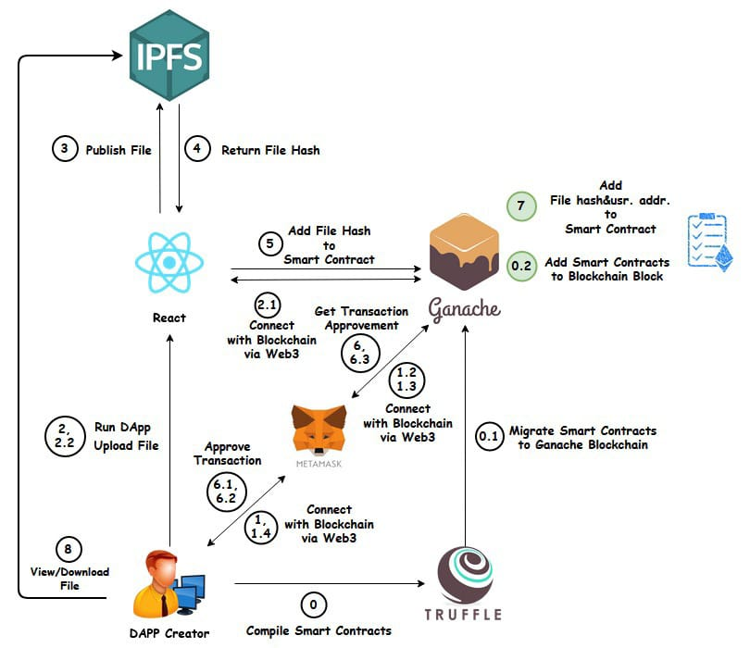

Image No.: 02 Architecture of DC-Storage

Here's the application that will work, Instead of talking to a web server, a centralized version of Cloud Storage. We're going to build a decentralized version where you use your web browser and you connect with a blockchain wallet to the blockchain. And this is where we will store all the code for our application inside of Smart contracts. We're going to use a ethereum. So we'll write Ethereum Smart contracts to store the location of the files, and then we'll store these files on the interplanetary file (IPFS system).

So IPFS this will work a lot like a blockchain, but it's a different way of storing files. Also decentralized. And this will allow us to store these files here for free for the long term, and then also there'll be censorship resistant. No central party can take them down. And here is a technical diagram of how this application will work.

So these are all the technologies that we'll use to build this application. So we'll see this here in a minute. We install the dependencies and also as we build the project. But basically a user will interact with the application that we build and react JS and this application will talk to the blockchain. So we're going to talk to Ethereum in this tutorial, and we'll use a blockchain called the Ganache, which is a development version of Ethereum.

Our React application will also talk to IPFS, the interplanetary file system whenever we upload these files. So we'll upload to IPFS. We'll develop Smart contracts that store the location of these files. We'll put them on Ganache, and then this will allow the user to view and download files from this React application as well as upload and store them.

**3.4 User Interface Design**

The user interface (UI) is the point at which human users interact with a computer, website or application. The goal of effective UI is to make the user's experience easy and intuitive, requiring minimum effort on the user's part to receive maximum desired outcome.

UI is created in layers of interaction that appeal to the human senses (sight, touch, auditory and more). They include both input devices like keyboard, mouse, trackpad, microphone, touch screen, fingerprint scanner, e-pen and camera and output devices like monitors, speakers and printers. Devices that interact with multiple senses are called "multimedia user interfaces". For example, everyday UI uses a combination of tactile input (keyboard and mouse) and a visual and auditory output (monitor and speakers).

Other types of user interfaces can include:

* Form-based user interface: Used to enter data into a program or application by offering a limited selection of choices. For example, a settings menu on a device is form-based.
* Graphical user interface: A tactile UI input with a visual UI output (keyboard and monitor).
* Menu-driven user interface: A UI that uses a list of choices to navigate within a program or website. For example, ATMs use menu-driven UIs and are easy for anyone to use.
* Touch user interface: User interface through haptics or touch. Most smartphones, tablets and any device that operates using a touch screen use haptic input.
* Voice user interface: Interactions between humans and machines using auditory commands. Examples include virtual assistant devices, talk-to-text, GPS and much more.

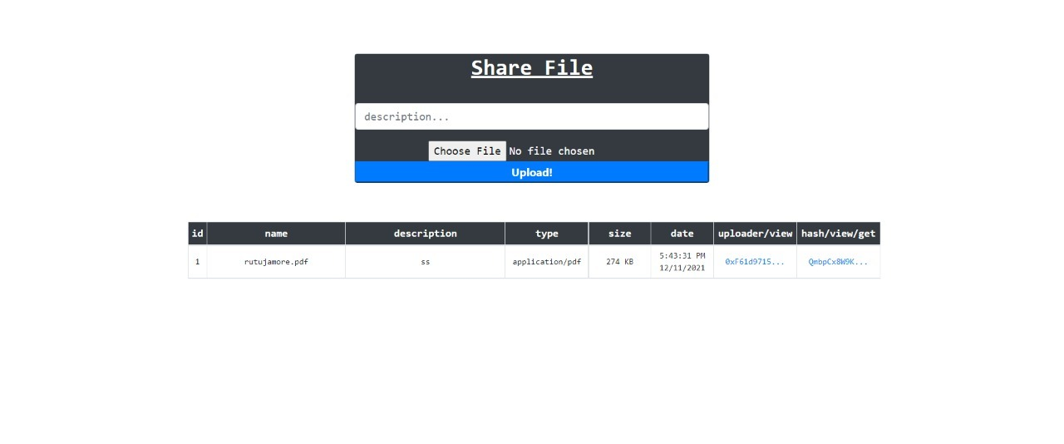

UI of DC-Storage

**Chapter No. : 04**

**4.1 SCREENSHOTS**

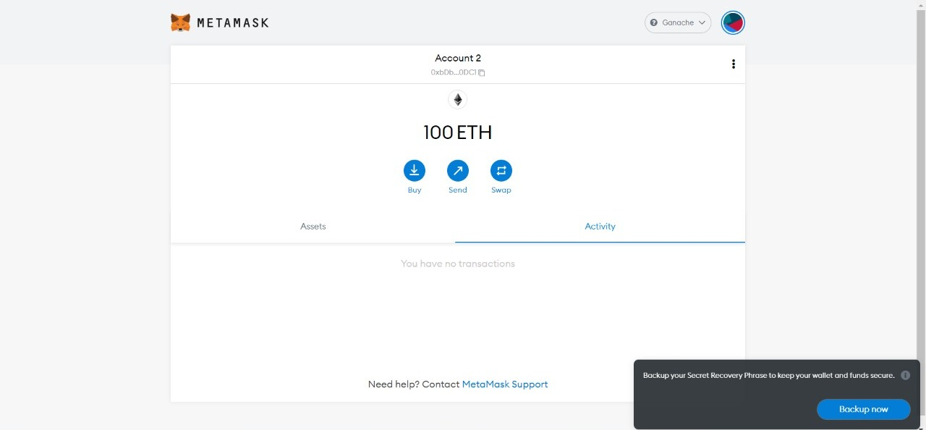

**Screenshot No.01: Ethers Added to metamask Wallet**

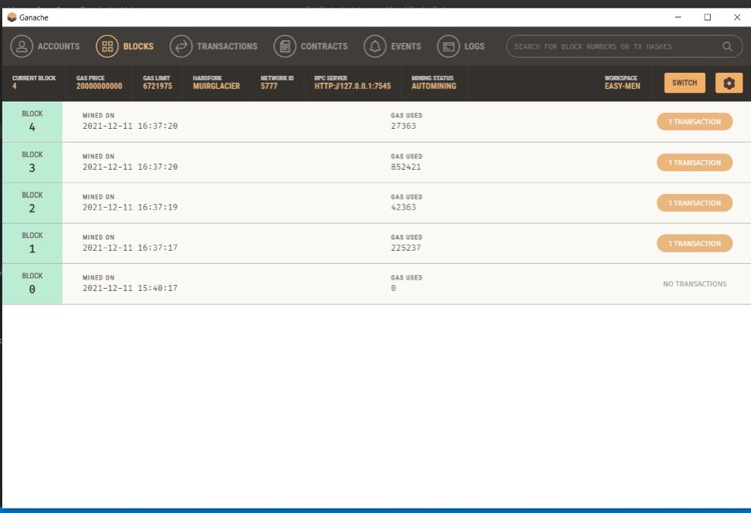

**Screenshot No.02: Blocks (Ganache)**



**Screenshot No. 03: UI of Dc- Storage**

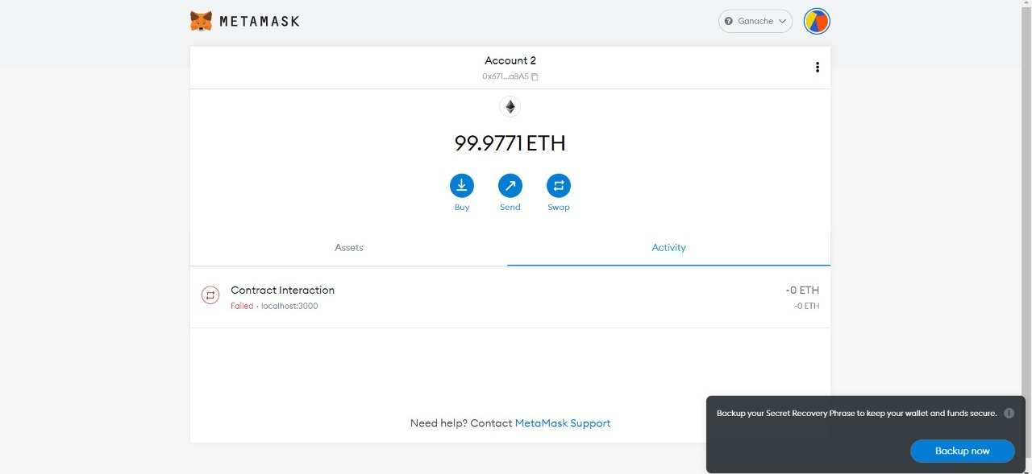

**Screenshot No. 04: MetaMask Wallet where Transaction is done**

**Chapter No. : 05**

**Performance Evaluation**

The major performances of this projects are listed below:

* It conducts a comprehensive review of blockchain-based trust approaches in cloud computing environment.
* It expands the boundaries of cloud computing to analyze the application of blockchain in the different implementation modes of cloud, including P2P, IoT, edge computing, etc., proposes a taxonomy of blockchain-based schemes and gives an in-depth analysis of the current approaches.
* It proposes a novel cloud-edge hybrid framework and a double-blockchain based transaction model for the flexible trust management.
* It identifies research gaps and suggests future research directions in blockchain-based trust management in cloud computing.

Being an emerging decentralized framework and a distributed computing paradigm, blockchain technology has received widespread attention, and its application has shown a blowout development with the popularity of digital cryptocurrencies. Blockchain is based on a decentralization P2P architecture, where all the nodes are equal and no control center exists. The benefits are:

maintenance of trust relationships no longer depends on a third-party center, and the damage from a few nodes isn’t able to destroy the robustness of the system, the operating rules and data records are open, transparent and traceable, and the chain data structure and the consensus mechanisms ensures the integrity, credibility and security of trust evidence.

Obviously, the decentralization feature of blockchain is particularly suitable for constructing a new distributed and decentralized trust model. Blockchain provides a new way to achieve trust-enabled cloud trading environments. To date, several blockchain-based trust management approaches have been put forward. These new studies have proved the overwhelming advantage of blockchain-based schemes. For instance, the blockchain-based detection algorithm improved the accuracy by 5% to 15% . The rewards of NFV (distributed network function virtualization) in MEC environments were increased to 6 ~ 7 times using blockchain-enhanced method. When processing large-capacity data requests, the delay of the blockchain-based method is only 1/5 of that of the traditional ones.

**Conclusion**

Both blockchain and cloud computing are playing a vital role in changing enterprises’ work environments and the way traditional computing works.

Their emergence has not only gained momentum in the existing business infrastructure but has also changed the way the world of application development, storage, online transaction, and other services functions. Although cloud is a well-oiled model that can accelerate blockchain projects, their merger and blockchain cloud services are still in infancy.

**References**

[1] https://www.linkedin.com/pulse/6-reasons-why-use-cloud-storage-blockchain-future-amirsan-roberto

[2] https://medium.com/@katie.holland.runs.fast/data-flow-diagram-vs-use-case-diagram-674af6ca8c2f

[3] Turkish Journal of Computer and Mathematics Education Vol.12 No.11 (2021), Research Article 1515 Blockchain Techniques for Secure Storage of Data in Cloud Environment

[4]

**ACKNOWLEDGEMENT**

I would like to place on record my deep sense of gratitude to Prof. S. B. Kalyankar, HOD-Dept. of Computer Science and Engineering, Deogiri Institute of Engineering and management Studies Aurangabad, for his generous guidance, help and useful suggestions.

I my sincere gratitude to Prof. K. V. Reddy, Dept. of Computer Science and Engineering, Deogiri Institute of Engineering and management Studies Aurangabad, for his stimulating guidance, continuous encouragement and supervision throughout the course of present work.

I am extremely thankful to Dr. Ulhas Shiurkar, Director, Deogiri Institute of Engineering, and management Studies Aurangabad, for providing me infrastructural facilities to work in, without which this work would not have been possible.

**Signature of Student**

Rutuja Umakant More 